Introduction / Overview

I embarked on this project with the aim of supporting my college friends who are considering their studies with part-time jobs. Many of them are tutors who often have difficulty managing their students' schedules and grades effectively.. To ease their burden, I decided to develop a solution that would simplify the process for them. My goal was to create an application that would allow them to easily store class schedules, track student scores, and ultimately improve their overall productivity. By working on this project, I aim to provide them with a reliable tool to help streamline their responsibilities and help them succeed both academically and professionally.

- Domain of the project
- Quick introduction to possible technologies / methodologies

Git gitbub, gitlab android studio, firebase sqlite,
1. React Native
React Native is a framework that is very helpful in making mobile applications. Using JavaScript and React, React Native allows developers to create mobile apps for Android and iOS platforms with efficiently reusable code. React Native also offers fast performance and a responsive user interface.

2. Flutter
Flutter is a very famous framework in making mobile applications made by Google. Using the Dart programming language, Flutter allows developers to create mobile apps for Android, iOS, and even desktop platforms with a natively rich user interface. Flutter also offers a fast development experience, fast UI updates, and consistent app results across multiple platforms.

3. Native (Java/Kotlin for Android, Swift/Objective-C for iOS)
Mobile app development using native programming languages, such as Java or Kotlin for
Android, and Swift or Objective-C for iOS, provides full control over platform features and
optimal performance. Native development usually takes longer and requires a deeper
understanding of the programming language and platform used, but it can provide highly
optimized and high-performance applications.

https://www.maxmanroe.com/best-technology-to-build-mobile-app.html

Key phrases

Aim
I built this mobile application to help those who are working as tutors manage their schedules and students more easily. To complete this project, I had meetings with my tutor friends to ask what their needs were. Then I choose the features that everyone wants to build the application.
First, I will build wireframes to showcase the user interaction flow. A wireframe is a draft design, containing the basic content of a mobile application interface, website or UI/UX application. I will have an overview of the application's interface and functions, thereby detecting problems early and making repairs. Next comes the design phase, where I create interface designs and demonstrate how to use the app. Then when the designs are formed, I will go into detailed work such as including themes, fonts, colors,... for the best user experience. Next is the programming and application development phase. it can last from a few weeks to a few months. Once completed, I will give it to my friends to try out to check if there are any errors or further modifications. If it's okay, I will give my application to more people who need to use it.

Objectives

Requirement

Activities
Collect and record all requests from application users such as tutors, students, parents. Learn about the app's functions, features, and goals. Focus on user interface and user experience.

Deliverables
The requirements of the system to be developed are recorded.

Design

Activities
Create architecture, design databases, and define overall system structure. Design the necessary functions for both tutors and students to be easy to see and use.

Deliverables
Describe in detail the application structure including the user interface and data structures in the application.

Development

Activities

Use technologies and tools to create the system.

Deliverables
Accomplish the development version of the system.

Testing

Activities
Test the requirements. application functions and application security. Fix errors according to test results so that the system works well.

Deliverables
The application works well before the user uses it.

Deployment

Activities
The application is ready to deploy once it has passed the testing stages.

Deliverables
The application is installed and provided to the end user.

Maintenance

Activities
Continuous monitoring and maintenance during application use. including fixing bugs found in production environments and deploying updates.

Deliverables
The system works smoothly. Best user experience

Legal, Social, Ethical and Professional
Discuss issues (LSEP) that related to you project and possible solution for that. BE SPECIFIC!

Legal

Social

Ethical

Professional

Plan
- WBS

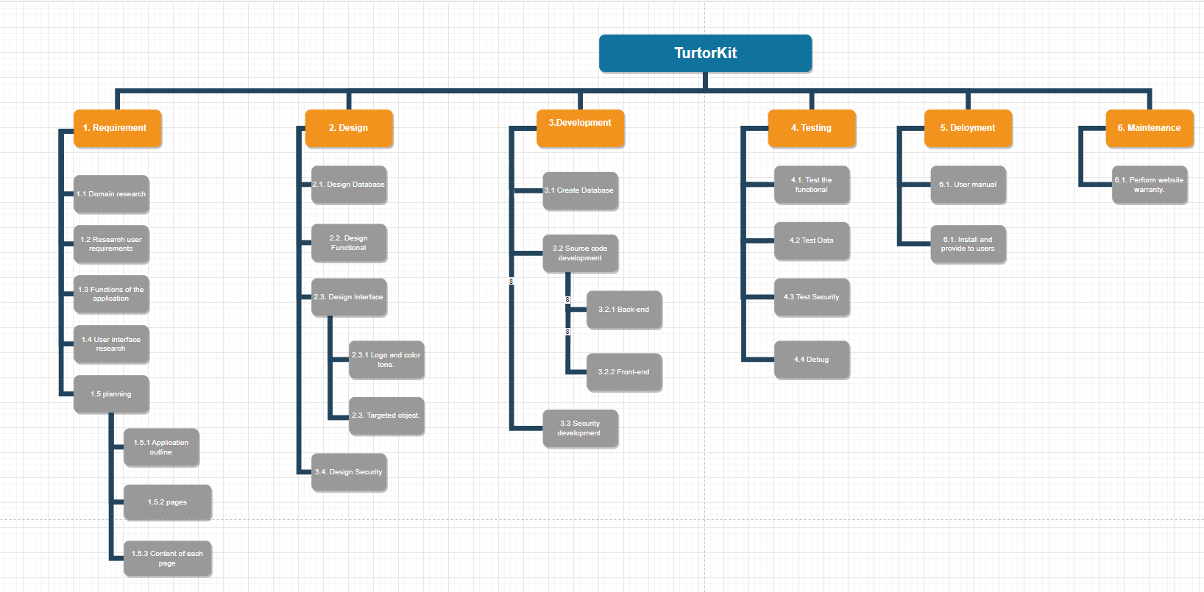
- Gantt Chart

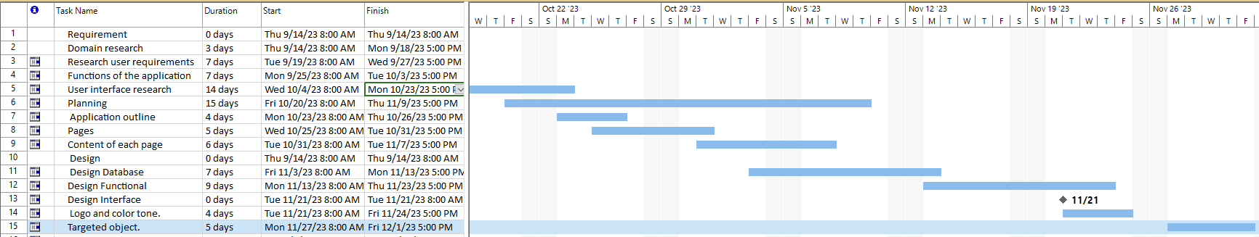
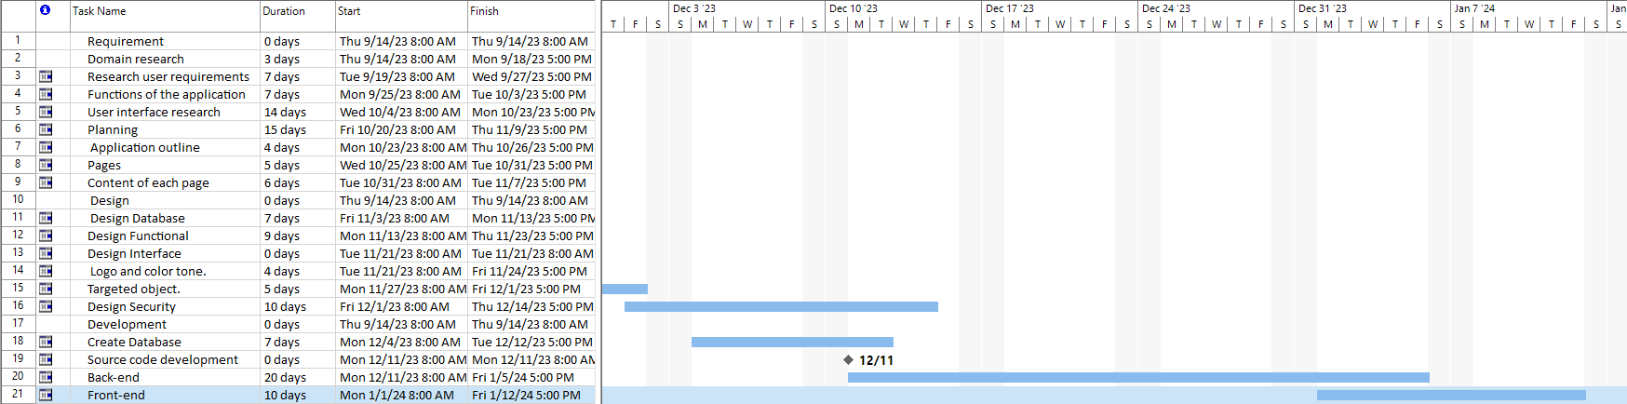
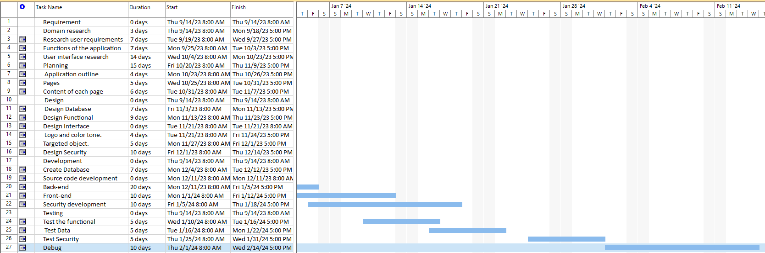
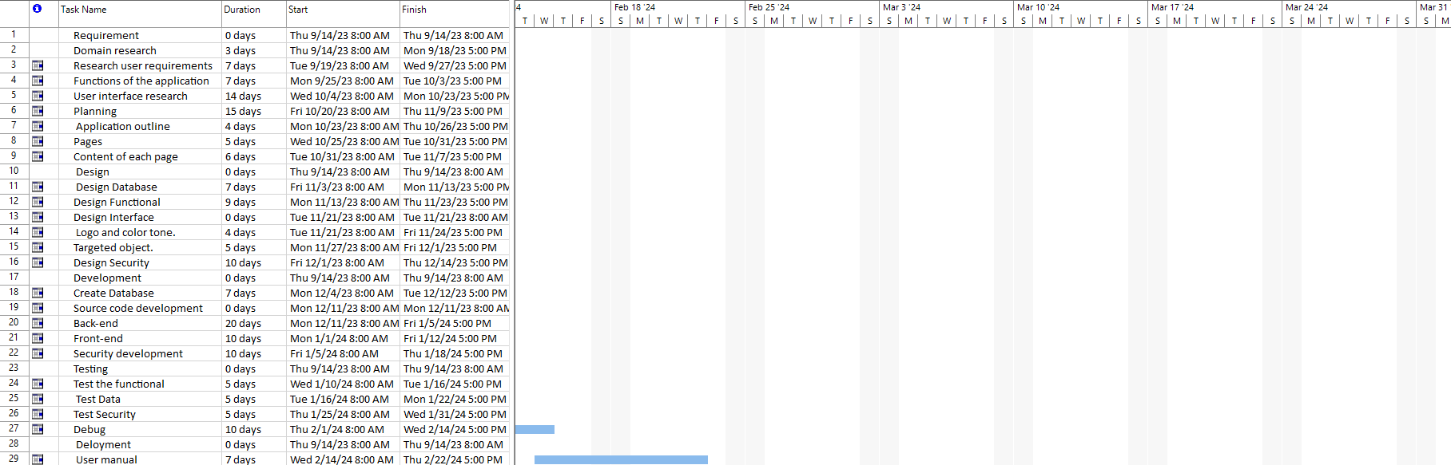
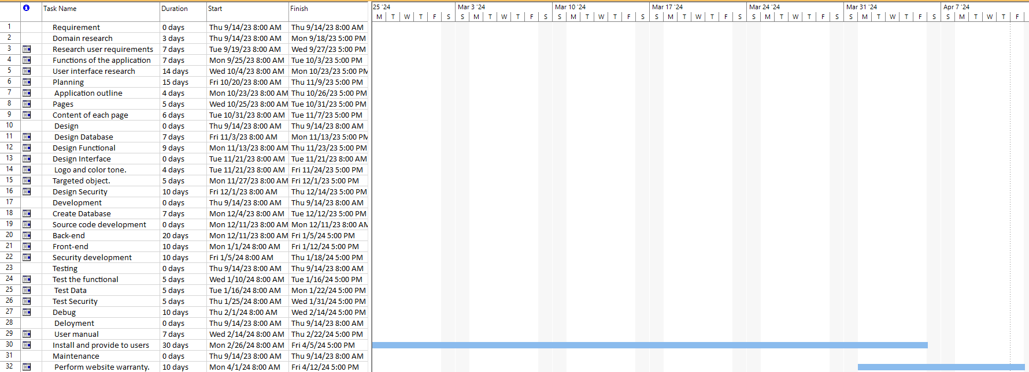

Initial References

https://www.maxmanroe.com/best-technology-to-build-mobile-app.html

